The information below shows a range of processes and outcomes from mentoring and these resonate with professional learning and development in CLD. This material might help you when considering what you want to get out of your professional learning and development and who would be best placed to support you in this from a mentoring perspective.
You might already have a mentor or mentoring system that you use with respect to your professional development at the moment and you might wish to consider how the CLD Standards Council’s Registration and Professional Learning requirements could be accommodated?
It also might be the case that it is not one person that is your mentor, that you a number of people that support you in this and in this case you would need to consider would be best placed in this respect to act as the verifier when it come to your 3 yearly registration review of professional learning and development and that they have the relevant professional understanding required.
It is useful to have an agreement between yourself and your mentor/s so that there is clarity of roles, responsibilities and expectations. A sample Mentoring Agreement document is provided with this advice which can be used and adapted if required.
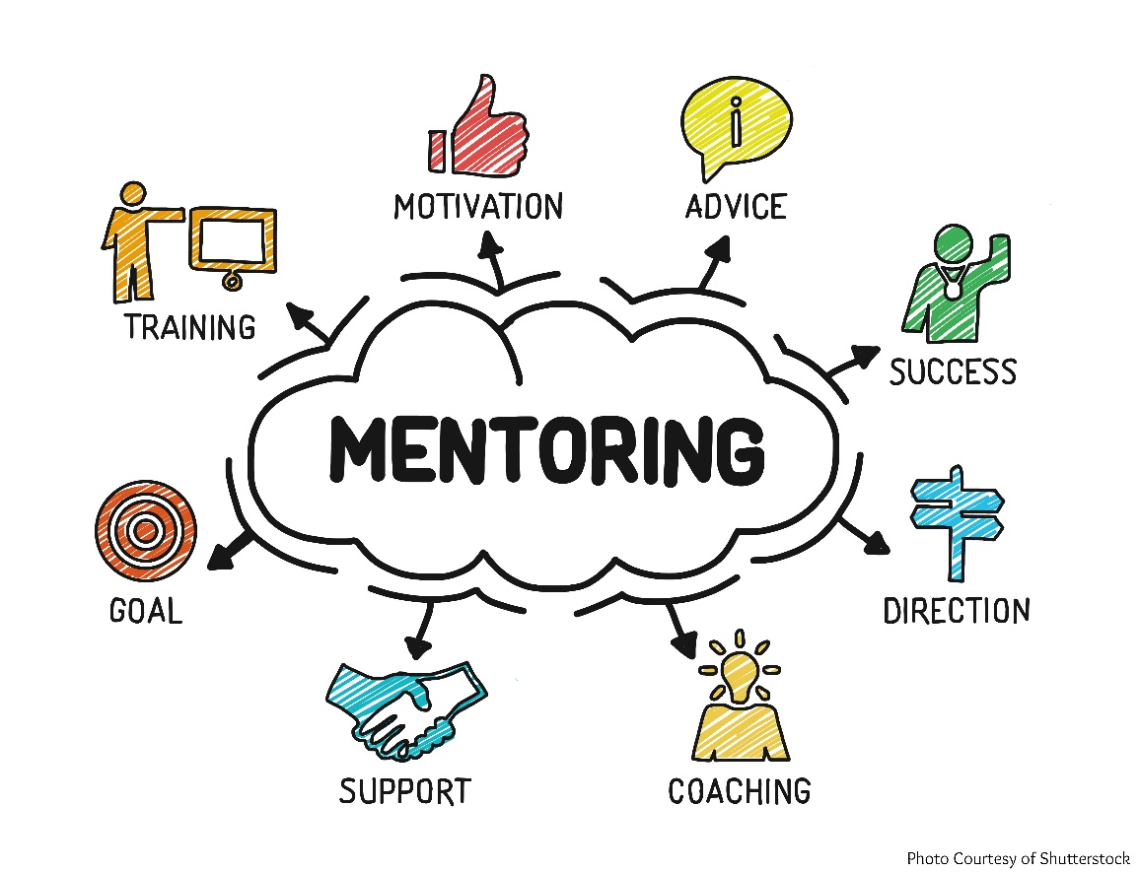

Coaching and mentoring defined (source GTCS)
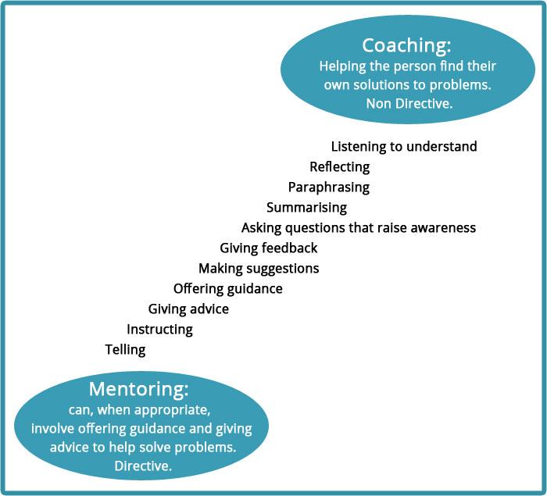

The terms coaching and mentoring describe a continuous two-way process through which the person in the role of coach, or mentor, uses questions, discussion and guided activity to help the person being coached, or mentored, to solve problems, address issues or do tasks to a higher standard than would otherwise be the case. The aim of the process is to improve performance in "getting the job done" and make a direct contribution to the person's learning and development.

Coaching and mentoring are different activities but the key principles are similar. Common elements, in an educational context, include:
- a learning conversation;
- reflection and sharing;
- agreed outcomes;
- focus on learning and teaching;
- mutual benefit;
- confidentiality.

A mentor should have relevant and similar experience to the person being mentored, can act as a model and may offer advice. A coach need not share the knowledge base of the person being coached and will use questions to challenge thinking and promote reflection.

Benefit of coaching / mentoring
Hook et al. (2006) describe the benefits as:
- thinking more clearly about things;
- feeling valued and listened to;
- recognising and appreciating their skills and resources;
- increasing their range of options;
- clarifying how they’d like things to be as they get even better;
- understanding what they need to do to get there;
- becoming more creative and optimistic;
- feeling more positive and confident about change.

If used effectively, there is abundant evidence that coaching and mentoring empowers individuals, builds teams, enhances collegiality and improves morale across the team or establishment. As a result of feeling more in control individuals are more likely to accept responsibility both for their own learning and behavior and for the aims of the organisation as a whole.

Useful resources and Further Support e.g. i-develop, GTCS, SSSC, ES etc and links?

References
CLD Standards Council (2015) Growing a Learning Culture in CPD, http://cldstandardscouncil.org.uk/cpd/cpd-strategy/
Eraut M (2008) How Professionals Learning Through Work, University of Surrey
Hook P, McPhail I, Vass A(2006) Coaching and Reflecting Pocketbook, Hampshire, Teachers Pocketbooks
Kennedy A (2005) Models of Continuing Professional Development: a framework for analysis , Journal of In-service Education, Volume 31, Number 2
Schon D (1987) Educating the Reflective Practitioner: Towards a New Design for Teaching and Learning in the Professions, San Francisco: Jossey-Bass

