Student CLD Practitioner Welcome sheet

<Educational Provider logo>

<Welcome statement to be entered from Educational Provider>

Signed by appropriate member of the Educational Provider

Message from the CLD Standards Council:
Community Learning Development Standards Council (CLDSC) would like to congratulate you on your acceptance to your learning programme. Further information about us
Your educational provider will be arranging induction for you as part of your learning experience but we wanted to introduce ourselves and introduce the CLD Professional Practice Placement Standards to you. This document is designed to support you, your Educational Provider and your Practice Placement Supervisor when it comes to the practice placement element of your programme. As a Professional Community Learning and Development (CLD) practitioner it will be important that you take responsibility for the quality of your learning and especially ensuring that you receive the best practice experience possible. It will be your responsibility to ensure these documents are used to support your experience. It could be said that this document forms a contract between you, your Educational Provider and your Practice Placement Provider/Supervisor. You are at the heart of this learning and so it is right that you take control to ensure you receive the best quality learning experience.
As part of your learning you have the opportunity to register as an Associate Member of the CLDSC (if you have not already done so). This link provides details of the simple process to do this.
If you wish to discuss this document further please contact CLDSC at contact@cldstandardscouncil.org.uk and title your email Practice Placement query.
Best wishes on your studies and CLDSC look forward to hearing how your studies are progressing.

Signed
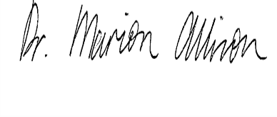
Director of CLD Standards Council Scotland

Have you filled in the name and date on front of your pack? y/n
Have you asked your tutor to fill in their name? (or has it already been done?) y/n
Have you visited the CLDSC website? y/n
Have you registered as an Associate Member of CLDSC? Y/N if not, why not?
……………………………………………………………………………………………………..………………

Space for any other useful notes you wish to make………………………………

